PSET-1

Pulsar Candidate Light Curve Analysis

by Haley Bates-Tarasewicz

**Introduction**

Pulsars are rapidly rotating neutron stars that emit focussed beams of radiation. When these beams align with the Earth, a periodic signal is observed, some with periods as short as one milli-second. Determination of the period and light curve shape helps to determine the interior structure of the pulsar.

**Data**

In class on September, 11th 2015 EDT we obtained observations of a pulsar candidate. We used a Pico System I camera with a Fuji 50mm lens. The exposure time used was .5 seconds and the read time between exposures was .75 seconds. The exposure sequence was comprised of 100 individual frames, lasting approximately 125 seconds.

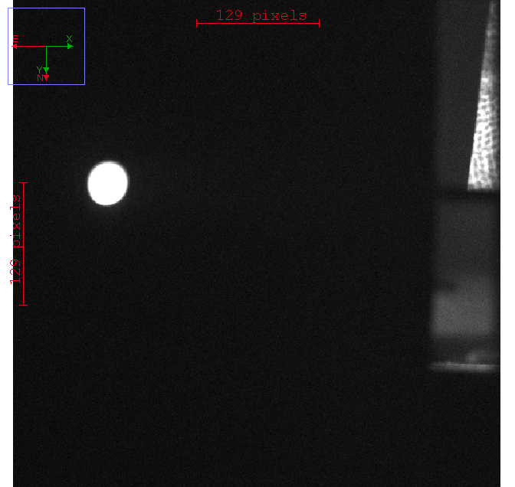

Fig. 1: Example image pulsar-105.fit from the collected dataset

I performed aperture photometry on this data set using AstroImageJ. AstroImageJ is an astronomy software that makes use of circular apertures and the annulus method.

The average background signal was determined to be 2006.98 from the analysis of Fig. 1. A similar analysis determined the total count of the signal from the background and the star to be 3884866.58. From this, it can be understood that the signal from the star itself is 3882859.6.

The aperture that was used to determine this was circular and made use of the annulus method. It was placed at x=98 and y=318 for all measurements.

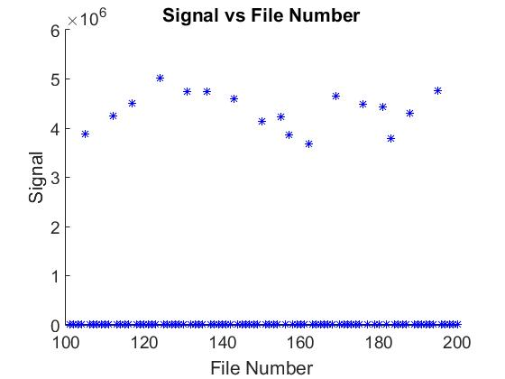

Fig. 2: A plot of the photon signal to the sequence number.

Fig 3. The table of Fig. 2

|  |  |  |  |  |  |
| --- | --- | --- | --- | --- | --- |
| File # | Signal | File # cont. | Signal cont. | File # cont. | Signal cont. |
| 101 | 1367.639329 | 137 | 1665.882704 | 173 | 1143.811497 |
| 102 | 967.216625 | 138 | 685.512177 | 174 | 2237.145472 |
| 103 | 1522.771394 | 139 | 1934.445995 | 175 | 1641.609326 |
| 104 | 1123.575091 | 140 | 1654.474073 | 176 | 4477349.164 |
| 105 | 3883135.78 | 141 | 1413.305388 | 177 | 2382.249479 |
| 106 | 1751.420641 | 142 | 1467.069486 | 178 | 1539.96242 |
| 107 | 1738.285902 | 143 | 4604581.539 | 179 | 888.685051 |
| 108 | 1289.811569 | 144 | 2025.410714 | 180 | 4435234.392 |
| 109 | 693.287631 | 145 | 1335.548061 | 181 | 2147.903482 |
| 110 | 1457.235817 | 146 | 2075.646237 | 182 | 3792760.965 |
| 111 | 1502.142545 | 147 | 2047.83528 | 183 | 1653.776847 |
| 112 | 4256869.231 | 148 | 1486.889239 | 184 | 2053.962285 |
| 113 | 2211.365277 | 149 | 1594.233043 | 185 | 1789.71709 |
| 114 | 1952.802073 | 150 | 4129913.985 | 186 | 1760.240863 |
| 115 | 1770.077083 | 151 | 2105.612993 | 187 | 4310792.652 |
| 116 | 1291.339527 | 152 | 1593.656419 | 188 | 2277.221952 |
| 117 | 4503289.272 | 153 | 2365.792505 | 189 | 1810.892862 |
| 118 | 1182.015948 | 154 | 2608.238806 | 190 | 879.08727 |
| 119 | 2001.56232 | 155 | 4229933.351 | 191 | 1454.675282 |
| 120 | 1481.125417 | 156 | 1764.611762 | 192 | 1399.04699 |
| 121 | 1209.547397 | 157 | 3858676.897 | 193 | 1805.518446 |
| 122 | 2400.480043 | 158 | 1106.231118 | 194 | 4766310.258 |
| 123 | 1799.099165 | 159 | 2476.949181 | 195 | 1751.764303 |
| 124 | 5019376.23 | 160 | 2145.084333 | 196 | 1548.36075 |
| 125 | 2383.419781 | 161 | 1886.980795 | 197 | 1032.180924 |
| 126 | 1694.007378 | 162 | 3674273.747 | 198 | 1181.346492 |
| 127 | 1487.867696 | 163 | 2202.762179 | 199 | 1661.906398 |
| 128 | 2389.602996 | 164 | 1905.595632 | 200 | 1661.906398 |
| 129 | 2290.831318 | 165 | 1588.28815 |  |  |
| 130 | 2173.471482 | 166 | 1294.008237 |  |  |
| 131 | 4750203.544 | 167 | 1141.720642 |  |  |
| 132 | 2683.285714 | 168 | 1957.53307 |  |  |
| 133 | 1880.229911 | 169 | 4644913.861 |  |  |
| 134 | 2278.361012 | 170 | 1497.897682 |  |  |
| 135 | 2060.715702 | 171 | 1548.366071 |  |  |
| 136 | 4748273.304 | 172 | 1009.346667 |  |  |

**Analysis**

The light curve in magnitudes is shown in Fig. 4

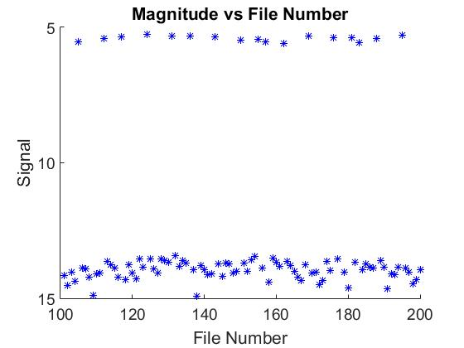

Fig. 4: A plot of magnitude to the image sequence number

Fig. 4: A table of Fig. 3.

|  |  |  |  |  |  |
| --- | --- | --- | --- | --- | --- |
| File # | Magnitude | File # cont. | Magnitude cont. | File # cont. | Magnitude cont. |
| 101 | 14.16007105 | 136 | 5.308660729 | 171 | 14.02531588 |
| 102 | 14.53619062 | 137 | 13.94588895 | 172 | 14.48989912 |
| 103 | 14.04341323 | 138 | 14.90996207 | 173 | 14.35411386 |
| 104 | 14.37349474 | 139 | 13.78360848 | 174 | 13.62576444 |
| 105 | 5.527043558 | 140 | 13.95335009 | 175 | 13.96182547 |
| 106 | 13.89152384 | 141 | 14.12440996 | 176 | 5.37244759 |
| 107 | 13.89969698 | 142 | 14.08387329 | 177 | 13.5575319 |
| 108 | 14.22368433 | 143 | 5.34202458 | 178 | 14.03122469 |
| 109 | 14.89771637 | 144 | 13.73371724 | 179 | 14.62813031 |
| 110 | 14.09117541 | 145 | 14.1858512 | 180 | 5.382708559 |
| 111 | 14.05822213 | 146 | 13.70711666 | 181 | 13.66996309 |
| 112 | 5.427274227 | 147 | 13.72176245 | 182 | 5.552611319 |
| 113 | 13.63834879 | 148 | 14.06930345 | 183 | 13.95380773 |
| 114 | 13.77335443 | 149 | 13.99362048 | 184 | 13.71851884 |
| 115 | 13.88001955 | 150 | 5.460147483 | 185 | 13.86803904 |
| 116 | 14.22239889 | 151 | 13.69155362 | 186 | 13.88606975 |
| 117 | 5.366175387 | 152 | 13.99401326 | 187 | 5.413607165 |
| 118 | 14.31844166 | 153 | 13.56505837 | 188 | 13.6064866 |
| 119 | 13.74657721 | 154 | 13.45913162 | 189 | 13.85526811 |
| 120 | 14.07352041 | 155 | 5.434166189 | 190 | 14.63992002 |
| 121 | 14.29344277 | 156 | 13.88337708 | 191 | 14.09308485 |
| 122 | 13.54925475 | 157 | 5.533903963 | 192 | 14.13541925 |
| 123 | 13.86236225 | 158 | 14.39038532 | 193 | 13.85849518 |
| 124 | 5.248375626 | 159 | 13.51520726 | 194 | 5.304544228 |
| 125 | 13.55699865 | 160 | 13.67138907 | 195 | 13.89131082 |
| 126 | 13.92771176 | 161 | 13.8105813 | 196 | 14.02531962 |
| 127 | 14.06858921 | 162 | 5.587071226 | 197 | 14.46561043 |
| 128 | 13.55418561 | 163 | 13.64258097 | 198 | 14.31905676 |
| 129 | 13.60001722 | 164 | 13.79992313 | 199 | 13.9484836 |
| 130 | 13.65711513 | 165 | 13.99767676 | 200 | 13.9484836 |
| 131 | 5.308219452 | 166 | 14.2201574 |  |  |
| 132 | 13.4283327 | 167 | 14.35610037 |  |  |
| 133 | 13.81447261 | 168 | 13.77072723 |  |  |
| 134 | 13.60594365 | 169 | 5.332555839 |  |  |
| 135 | 13.7149548 | 170 | 14.06129463 |  |  |

The maximum observed change in brightness is 9.6616 mag, although the brightness

change varies between 7.8412 and 9.6616 mag. If this variation is due to photon noise within the data, the signal-to-noise ratio of these data is 32.8429.